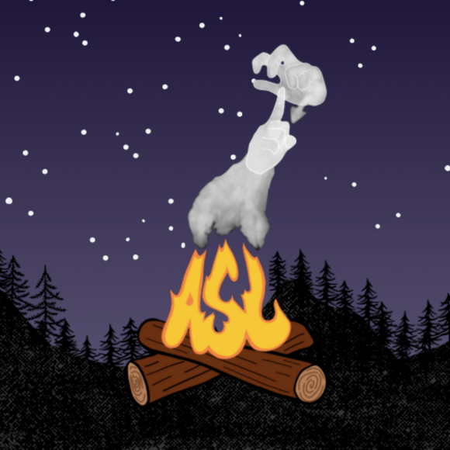
ASL IMMERSION RETREAT
PACKING LIST
ALL items listed are suggestions only. Bring what you need to be comfortable for the weekend.

PACKS
- Day pack/bag (optional)1 _____
Carry items from one location to another – for free signing hands
HEAD/NECK/HANDS
- Baseball cap/sun hat 1 _____
- Sunglasses 1 _____
- Light knit hat 1 _____
- Pair of light gloves 1 _____
CLOTHING FOR THE WEEKEND plus . . .
- Sweatshirt 1 _____
- Jacket 1 _____
- Rain jacket/suit 1 _____
- FRIDAY Shirt 1 _____
  - State Shirt
- SATURDAY Shirt 1 _____
  - CAMP Shirt (provided at check-in)
- SUNDAY Shirt 1 _____
  - ASL Shirt

FOOTWEAR
- Hiking shoes 1 _____
- Tennis shoes 1 _____
- Wool hiking socks 3 _____
- Other socks 4 _____
SLEEPING GEAR
- Sleeping bag/blanket 1 _____
- Sleeping pad 1 _____
Mattresses provided, this is for your own comfort
- Sleeping clothes 1 _____
- Pillow 1 _____
TOILETRIES
- Sunscreen 1 _____
- Non aerosol repellant 1 _____
- Toothbrush & paste 1 _____
- Shower supplies 1 _____

- Deodorant 1 _____
- Towels 2 _____
- Shower shoes 1 _____
MISC ITEMS
- Personal first aid kit 1 _____
- Camp chair 1 _____
- 1L Water bottle 1 _____
- Flashlight/headlamp 1 _____
*Make sure to have fresh batteries
- Watch 1 _____
- Lip balm 1 _____
- Personal meds _____
OPTIONAL
- Games/cards
- Power strip 1 _____
- Notebook/pencil 1 _____
- Camera 1 _____
- Phone 1 _____
- Portable charger 1 _____
- Closed toe sandals 1 _____
- Twin sheet 1 _____
- Extra blanket 1 _____
- Tennis/climbing shoes 1 _____
**Zip line participants

