Practice for the SPEC Test

Introduction to the SPEC test
- In this test, you will demonstrate how well you use English to perform a variety of functions related to classroom activities. There will be two main sections: impromptu speaking and an interactive presentation. If you qualiﬁed and received an exemption, you will only take the second section of the test.
- Before each task, you will receive instructions from the proctor. Each task is timed. The preparation time and the maximum speaking time will be stated at the beginning of each task. If you complete a task before the time finishes, it is not necessary to continue talking if you feel your answer is complete.
- During the test, test takers are not permitted to read from a pre-prepared script or use outside assistance (e.g. AI). When test takers don’t follow instructions, the scores may be canceled.
- The test will be recorded. The test taker’s face should be fully visible during the test. If technical difficulties interfere with the recording, the proctor may interrupt, and if they cannot be resolved, the test may be rescheduled.
- Your score for the test will be based on this recorded speech sample. These recordings are evaluated by at least two trained raters. Recordings are saved on a secure University server for five years after test administration.
- The total length of the test is approximately 25 minutes.

Task 1: Impromptu Response
Preparation Time: none Speaking Time: 2-3 minutes

We will ask 1-3 questions about educational experiences. We will talk for up to three minutes. (Below are some example questions. During the actual test, you will not see a list of questions. We will ask questions in an interview format. We will talk for up to three minutes total, not three minutes per question.)

To practice, set your timer for three minutes and answer some of the following questions.
- Describe your favorite class.
- Tell me about a time when you struggled at school.
- Tell me how someone should prepare to study abroad (at a university in your home country).
- In your previous institution, if you didn’t understand some material from class, what did you do?

When you are done, go on to the next page.

Task 2: Announcement of changes
Preparation Time: up to 30 seconds Speaking Time: up to 2 minutes
- For this task, imagine that you are a TA of an undergraduate-level class, and the professor sent information to the students earlier in the week. However, the professor has made some changes. I would like you to announce the corrections to your students as if you were in the classroom and I am your student.
- You will have 30 seconds to study the information and prepare your announcement.
- When you are told to begin, you will have up to 2 minutes to present the information. You will be able to see the announcement the entire time.
- Remember: Finishing before the timer or not finishing all the information will not impact your score.

- Set your timer for 30 seconds and study the information below.
- Set your timer for 2 minutes and announce these changes to your students: Yellow = old, green = new.
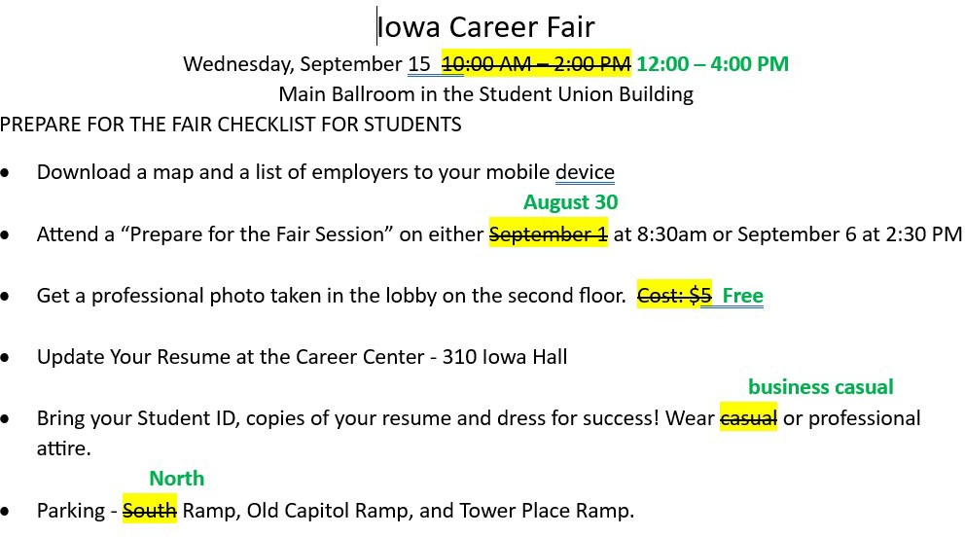

When you are done, go on to the next page.

Task 3: Interactive Classroom Presentation
Preparation Time: 1 minute to set up before the presentation (e.g. share screen, take out notes) Speaking Time: 10 minutes
- You will now have 10 minutes to present your chosen topic clearly. You may use notes, but please don’t read from a pre-prepared script or use outside resources for language assistance.
- We will be your students, and we will interrupt with questions for you to address. When the timer is complete, we will stop wherever you are in the presentation.
- Because you will be answering questions, you may not finish everything you have prepared. This will not impact your score so please do not rush through the material.
- You can ask the audience questions during your presentation. This includes asking me to clarify questions that we ask you.
- If you have a visual that you would like to share, please do that now.
Set your timer for 10 minutes and present the information you have prepared. When the time is finished, stop your presentation.

You are now ﬁnished with the practice test.

